Scalefocus Mid-term

Mihail Elencevski

Part 1:

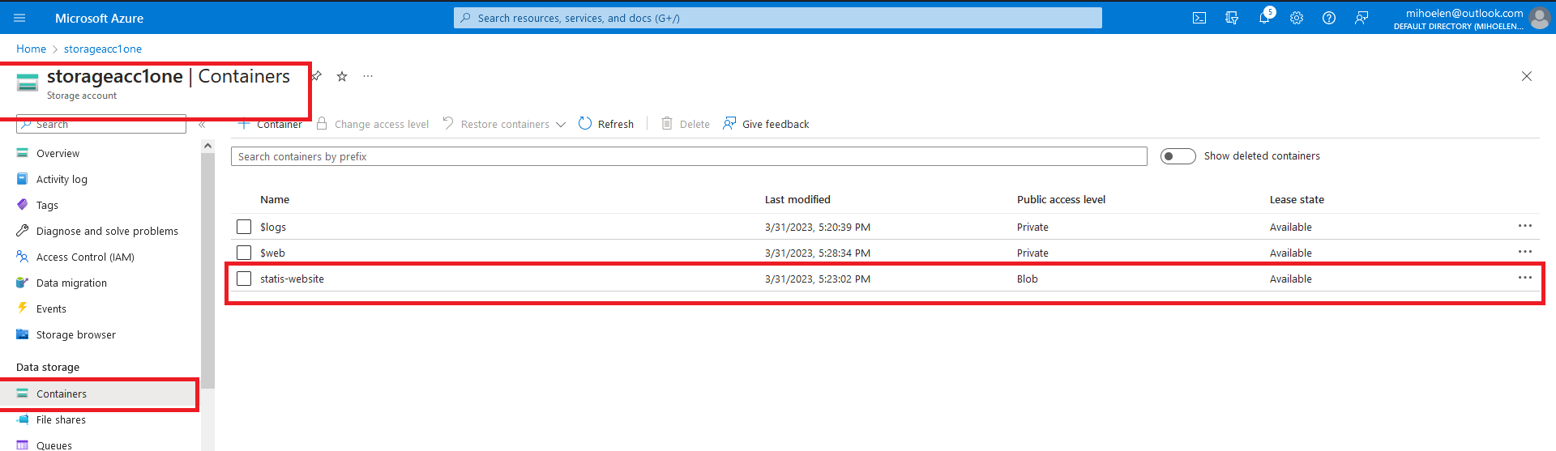

This is the URL: https://storageacc1one.blob.core.windows.net/statis-website/index.html

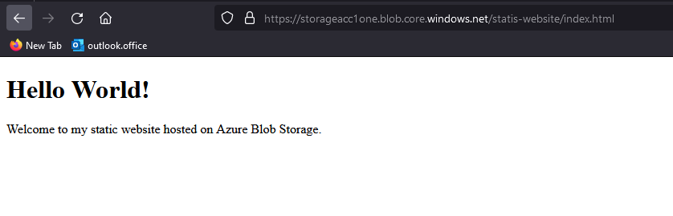

Part 2:

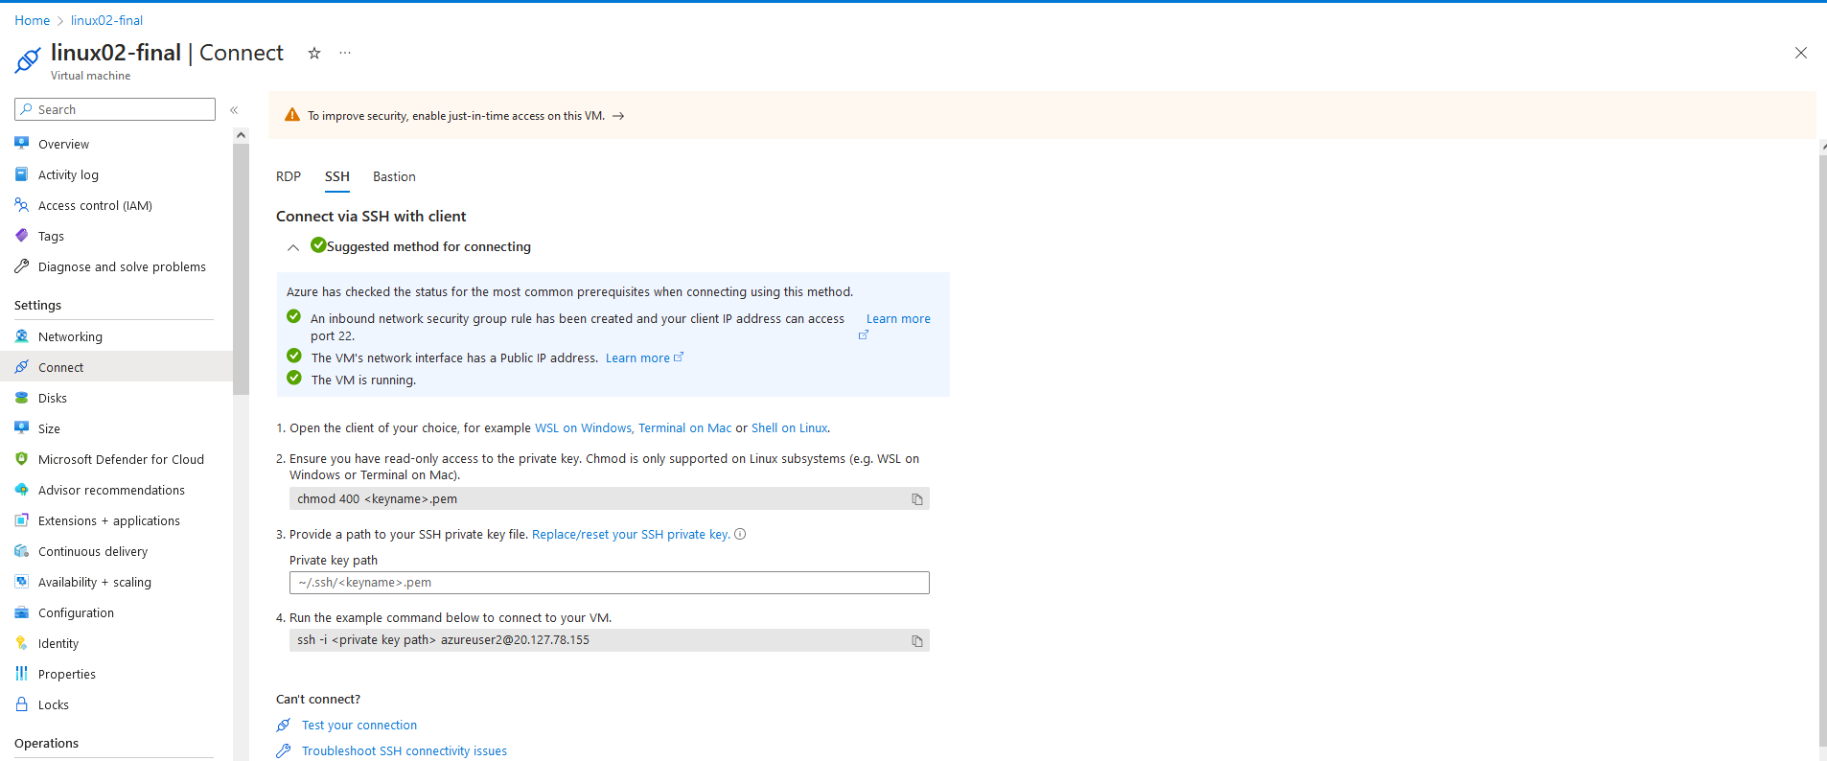

This is the NSG. The first is my public address.

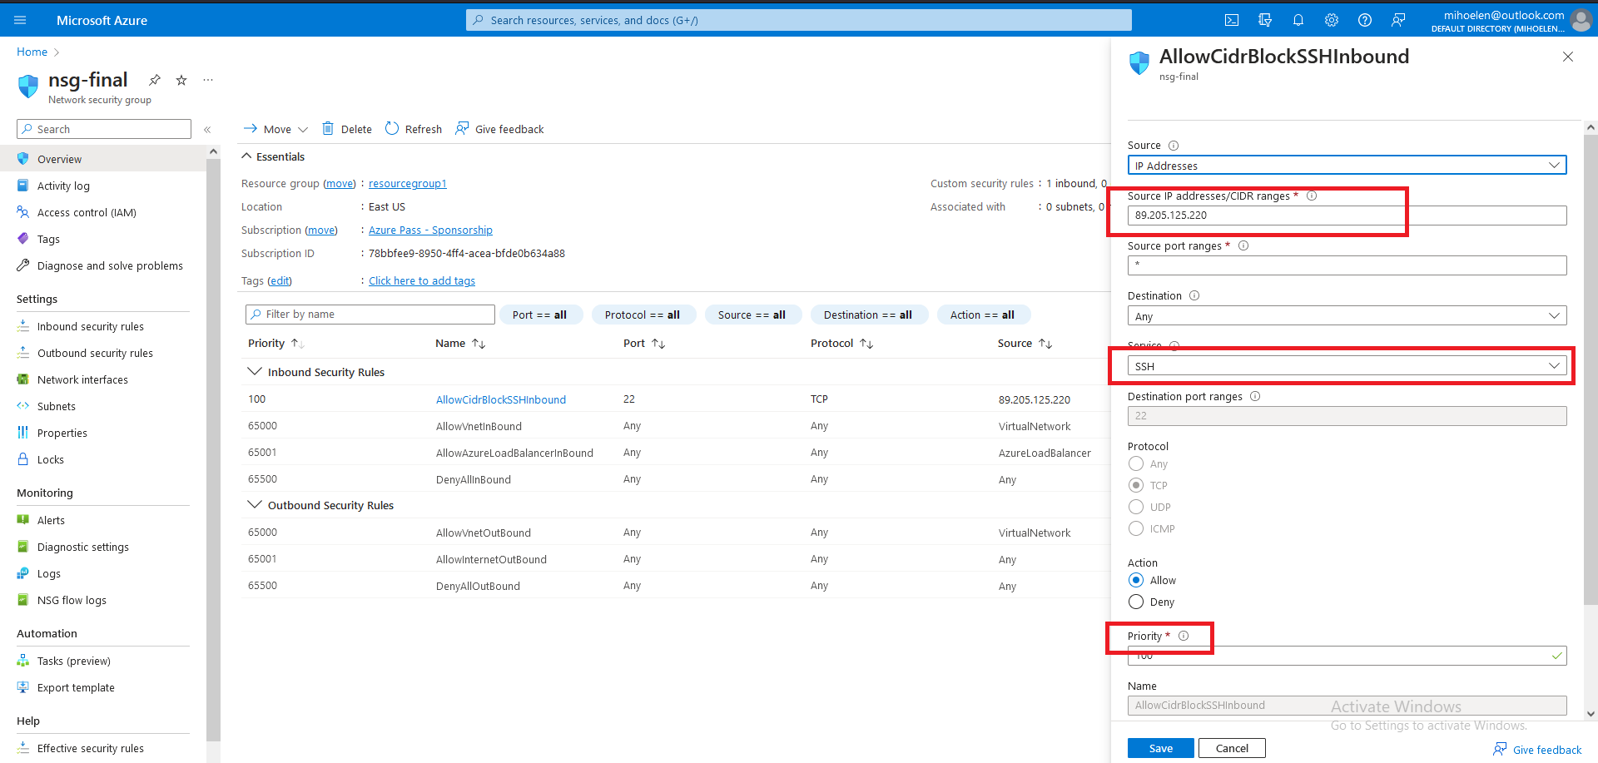

I tried to do it with RDP but it didn’t work so I am trying with SSH now.

I downloaded putty and as host name I uploaded the public ip address of the VM. But when I try to insert/upload the private key it doesn’t work. I cant find the file even though its downloaded.

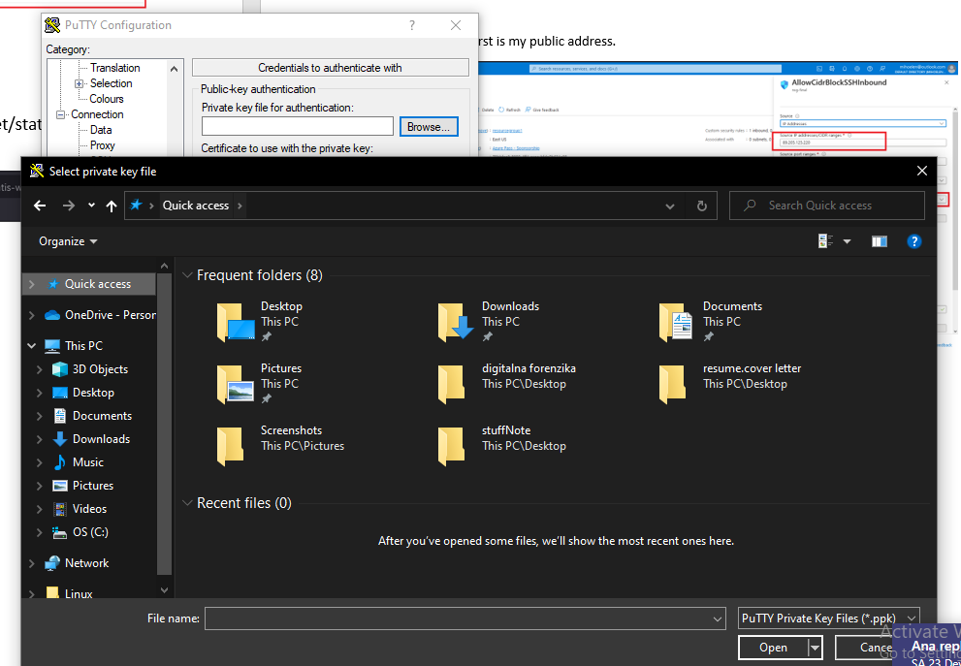

Here I downloaded apache and doing apt-update.

sudo apt-get update

sudo apt-get install apache2

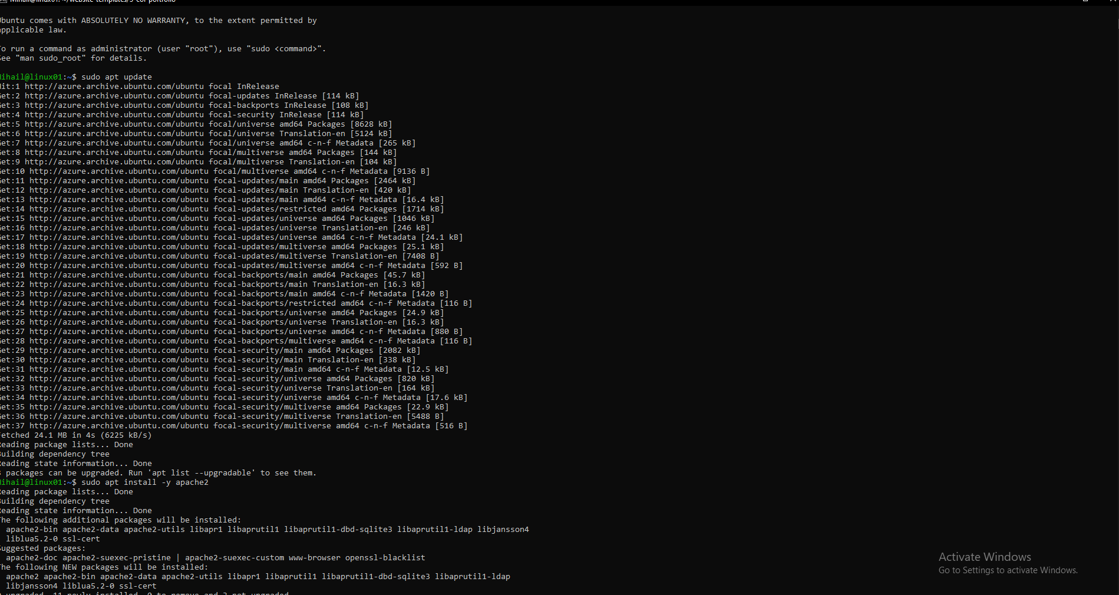

After installment I created a index.html hello page and I have to place it in appropriate directory for the Apache installation, like /var/www/html.

I am having a lot of trouble with SSH and I wasted a significant amount of time on that part.